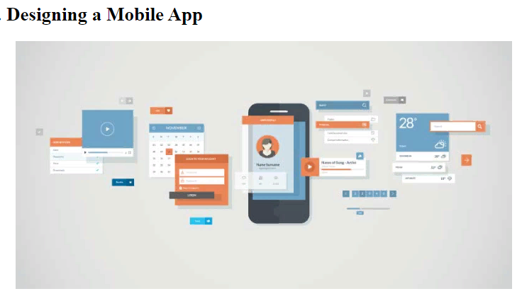

Guruh shaklida (4- 5 kishi) Mobil Ilovangizga (3 sahifadan iborat) dizayn yarating. Bunda Canva va figma kabi dasturlardan foydalanishingiz mumkin.